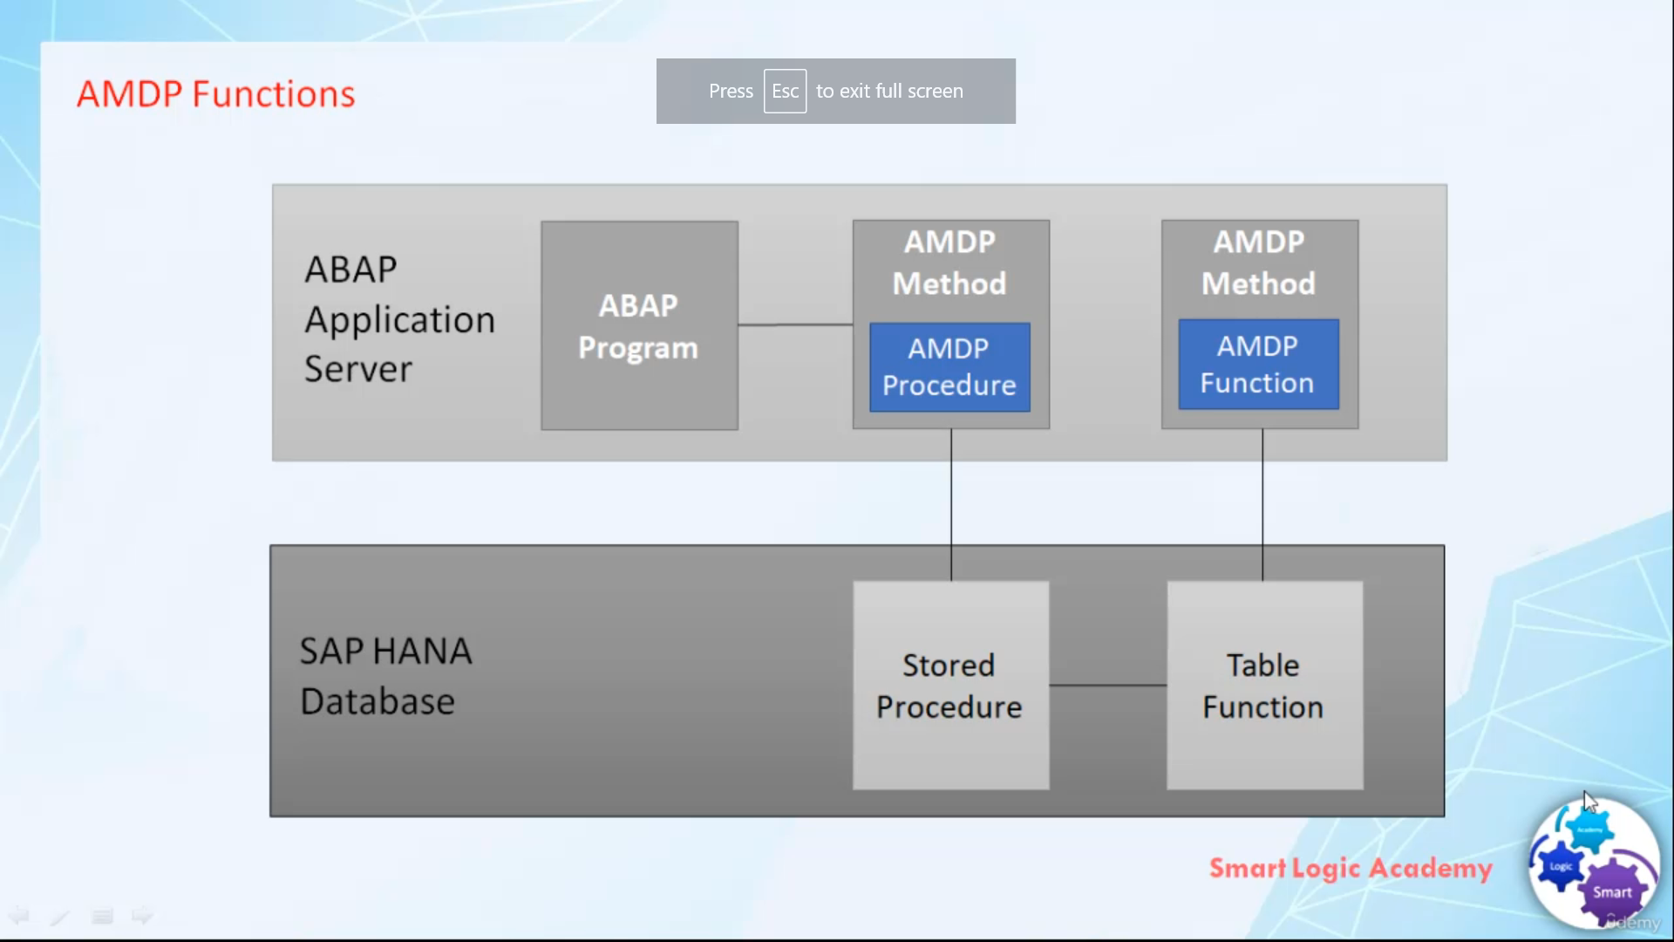

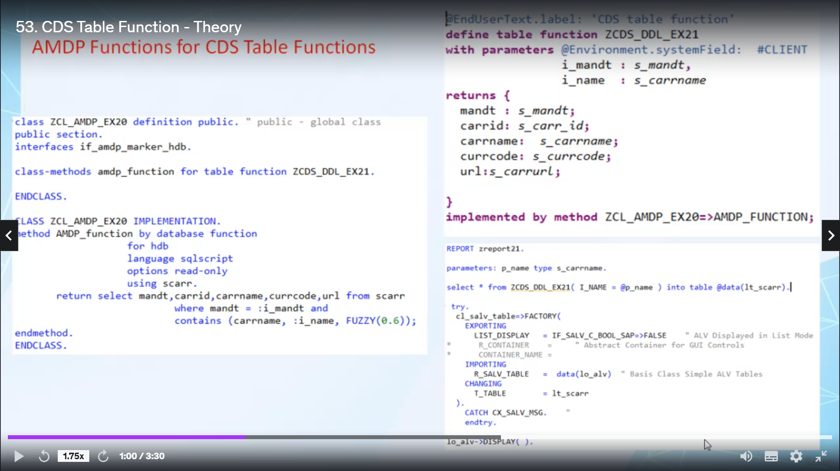

Hi, welcome back.

In this video.

I will tell you about MVP functions.

And how we can use in different functions in a relatively stable functions.

So let's start.

As of Rylstone, one five zero MGP framework supports MGP functions alongside the existing MGP procedures.

And functions cannot be called by the program directly, but they can be called from other military

functions or procedures.

And different functions use new additions by database function of the method statement in MGP classes.

Unlike in the procedure implementation.

And function implementation have no export or changing parameters.

They have exactly one Tablo return value.

And we function implementations cannot be called by program directly.

But they can be called from other interview functions or procedures.

In this critical financial statement, the return is mandatory.

The written statement defines the value for return barometer's.

MTV functions are functional meters of global glasses, which defines functions stored and executed

on database.

It is not allowed to call functional methods that defines MGP functions directly.

In Habab program, a website is introduced Christobel function to make aimed a few functions available

as datasource or select statement.

A celestial function is defined in detail, so by a key word differentiable function, just like cities

who are defined in detail by a keyword defining view, the definition of cities they will function refers

to an existing differential function via addition implemented by an Abbott program or cities.

You can use cities that will function as a datasource in the from clause of select statement, just

like it would do with cities view, database view or transplantable.

The city's framework excludes select from serious table function by calling the same function on database.

The elementalist of specific seeds must have an explicit Glenfield with built-In dictionary type Colline

as its first element.

That's it for now.

I hope you understood it.

Have a nice day.